Dimensional Model Hands-On Project

Elbio Iseas

DBM/460

October 10, 2016

Daniel McDonald

**Introduction**

In this phase of the development of the Dimensional Model, will refine the Data Warehouse at the Logical Model level by defining the primary and foreign keys on the Fact Entities and the primary keys on the Dimension Entities as well as Cardinality in the relations.

Before the ETL processes, will have interviews with employees involved in the operations of data entry for orders, like data entry clerks, managers, and other staff directly related to the process of handling the process of ordering.

**Dimensional Model**

**LOGICAL DESIGN**

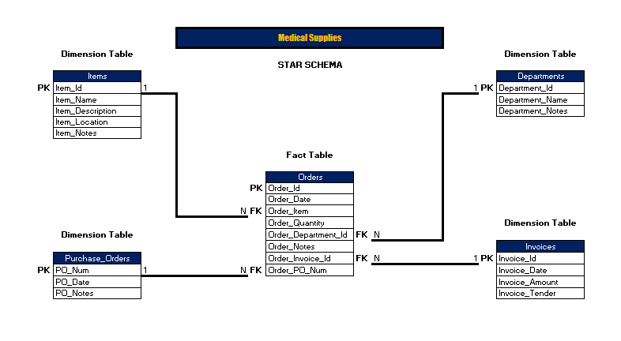

**ETL Processes**

The processes of Extraction, Transformation, and Loading (ETL) of data in the Dimensional Model will go through three steps:

* “Data Extraction” (Ponniah, 2010) makes sure to identify the different data sources (internal, external) considering from what Operating Systems, and files data are coming. In addition, it checks the compatibility of data structures from data sources independently if they are internal or external. All data extraction procedures are well documented and what they do.
* “Data Transformation” (Ponniah, 2010) uses methods to convert the data into a data structure that will fit the new structures when loading the data in the Dimensional Model. This transformation can include procedures like normalization, denormalization, checking the data that are non-complying with data structures in the Data Warehouse, making sure that the values are valid for accepting columns.
* “Data Loading” (Ponniah, 2010) starts by determining which will be the first load; the frequency the loads, what time of the day, how many times a day, what days of the week these load processes will run.

It is very important to load clean and valid data for helping decision makers go in the right direction about their decisions. This is the reason why information needs to be accurate, giving users the confidence needed regarding data in the data warehouse. The process of ETL has to ensure the quality of data to be loaded in the data warehouse.

There are different ways of end up with bad data sources. For instance data coming from migration processes, wrong integrations, input errors.

ETL process will avoid problems with data like multipurpose fields, contradicting data, non-complying with company policy and rules, non-unique identifiers, absence of data in source system fields (Ponniah, 2010).

ETL process will use SQL Server Data Tools to import data from data sources and then after the transformation the same tool can export data to the Dimensional Model.

**Conclusion**

The data warehouse will improve the speed of operations from the access to information point of view taking advantage of the star schema used for the dimensional model.

References

Ponniah, P (2010) Data Warehousing Fundamentals for IT Professionals, Second Edition. John Wiley & Sons, Inc.